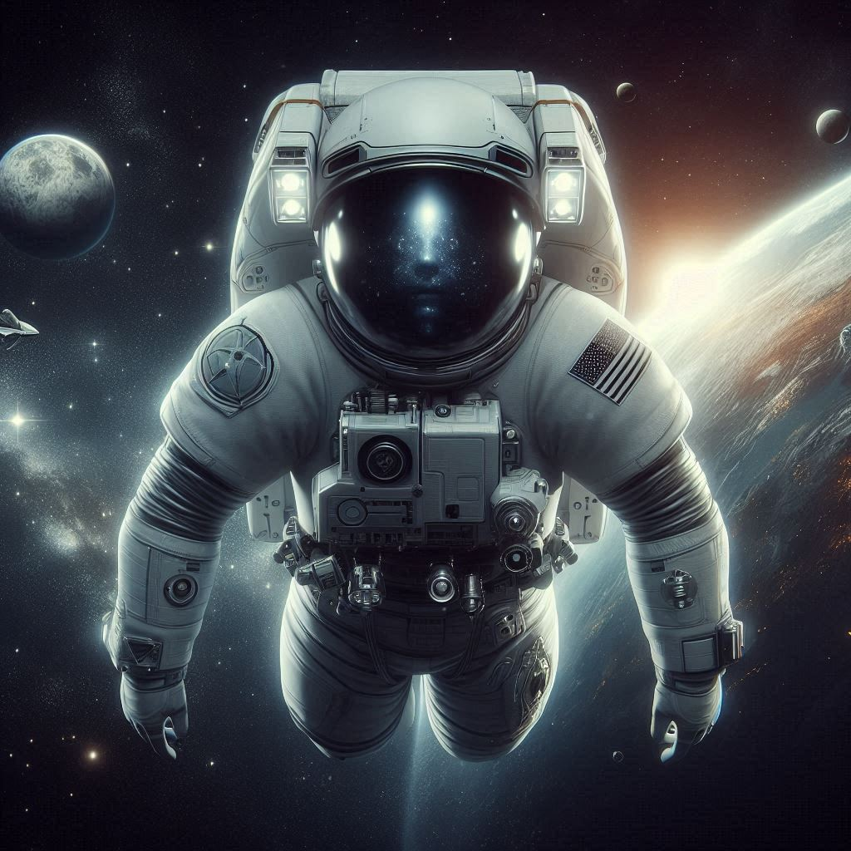



STEPS PODCAST
Creating A Website with docker
Progressive Pull Org ®

Contents
Installed Software 3
Introduction 3
Git 3
Check Git Version 3
Source Tree 4
NodeJS and NPM 5
Using NPM to download jQuery 5
GitHub Desktop 10
Visual Studio Code 11
Using the Debugger for JavaScript Application 11
Docker Desktop 14
Docker 15
Introduction 15
Docker File 15
Docker Image 17
Docker Container 17
Docker Compose 18
Create the Image 18
Images Menu 19
Starting the Container 20
Command Line 21
File Structure 21
Website in the Container 21
Difference Between RUN and CMD in Dockerfile 22
RUN instruction 22
CMD instruction 22
Summarize CMD and RUN instruction 22

Installed Software

Introduction
I’m not going to walk you through the installation process for this software. You can find plenty of tutorials on YouTube. Instead, I’ll provide you with a list of the software you need for your machine.

Git
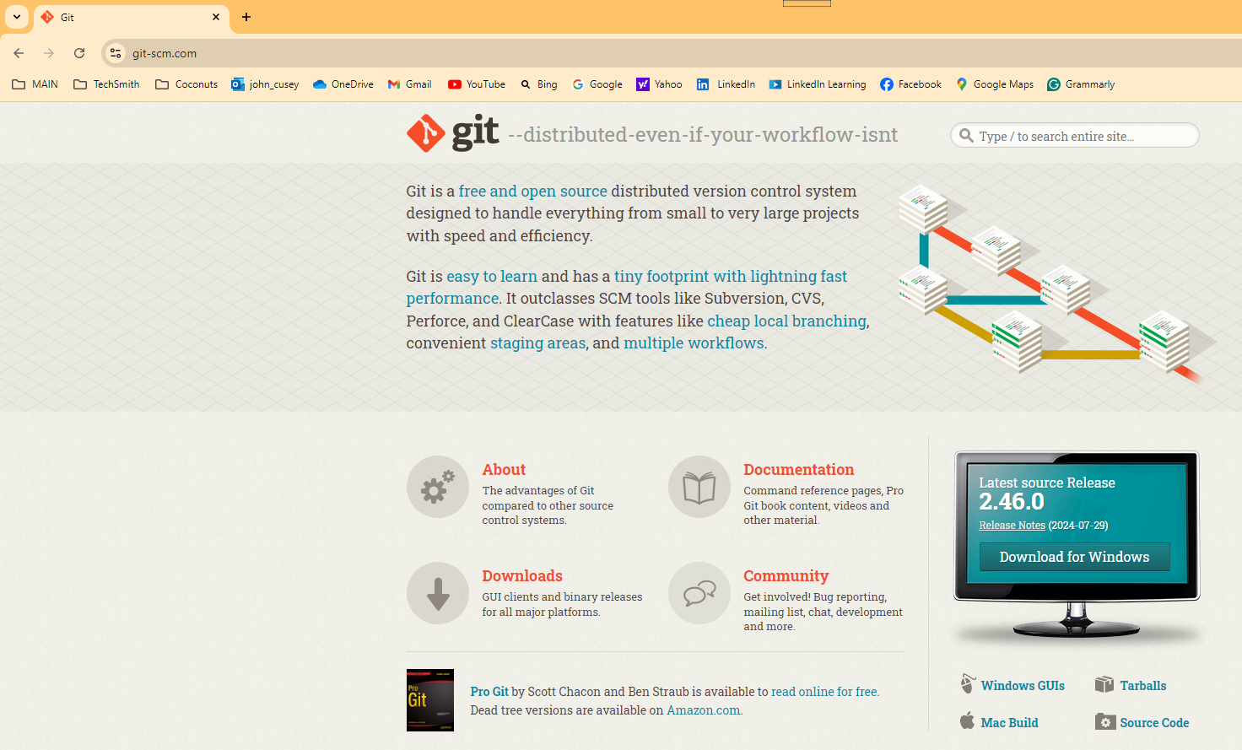
One essential software package to install on your computer is Git—not GitHub or GitLab. Git is a distributed version control system, extensively used in software development. Think of it as the backbone of collaborative coding. When you're working on a project with multiple people, Git tracks all the changes made to the code, who made them, and when. This allows multiple developers to work on the same project at the same time without interfering with each other's work.
While Git, GitHub, and GitLab are all related to version control and managing code, they serve different purposes. After installing Git on your computer, you can access it with command-line window. GitHub is a web-based platform that uses Git for version control. GitLab is a web-based DevOps lifecycle tool that provides a Git repository manager.
https://git-scm.com/

Check Git Version
To verify if Git is successfully installed on your computer, you can check the Git version number. To open the Command Prompt Window, click the Windows Start button.
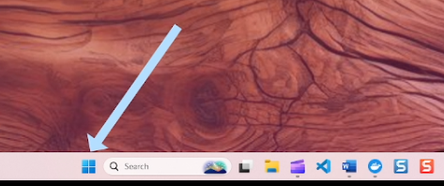
That will open the Start menu. At the top of the menu, there's a search field where you can enter 'CMD' to open the Command Prompt window.
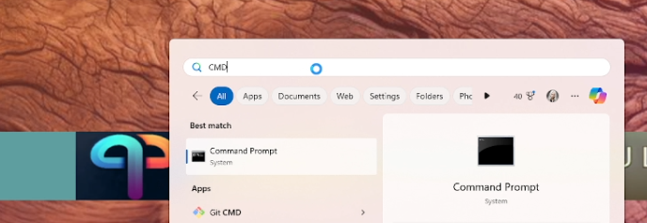
To see the version number, type 'git -- version' in the Command Prompt window.
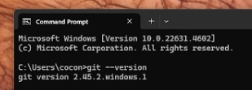

Source Tree
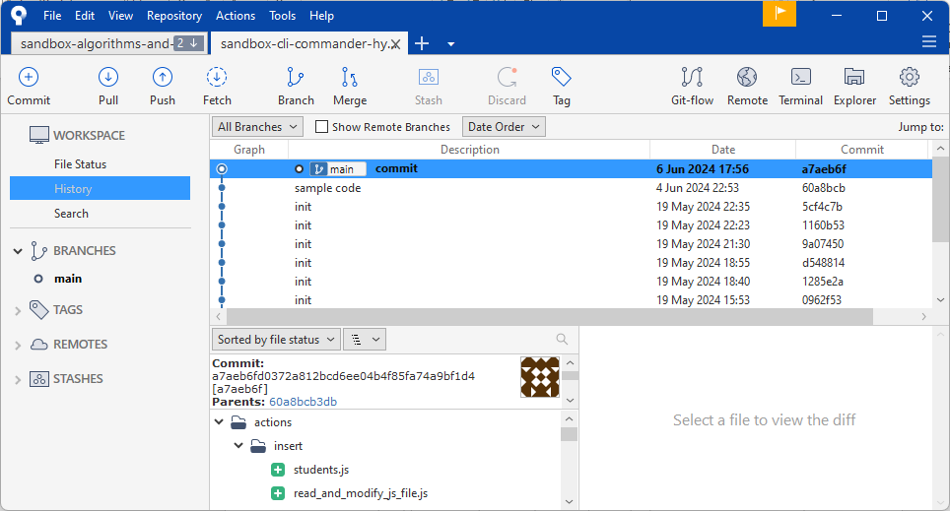
SourceTree is a free Git client developed by Atlassian. It provides a graphical user interface (GUI) for managing Git repositories, making it easier for both beginners and experienced developers to interact with Git without needing to use the command line
SourceTree simplifies how you interact with your Git repositories so you can focus on coding. Visualize and manage your repositories through SourceTree’s simple Git GUI.
https://www.sourcetreeapp.com/

NodeJS and NPM
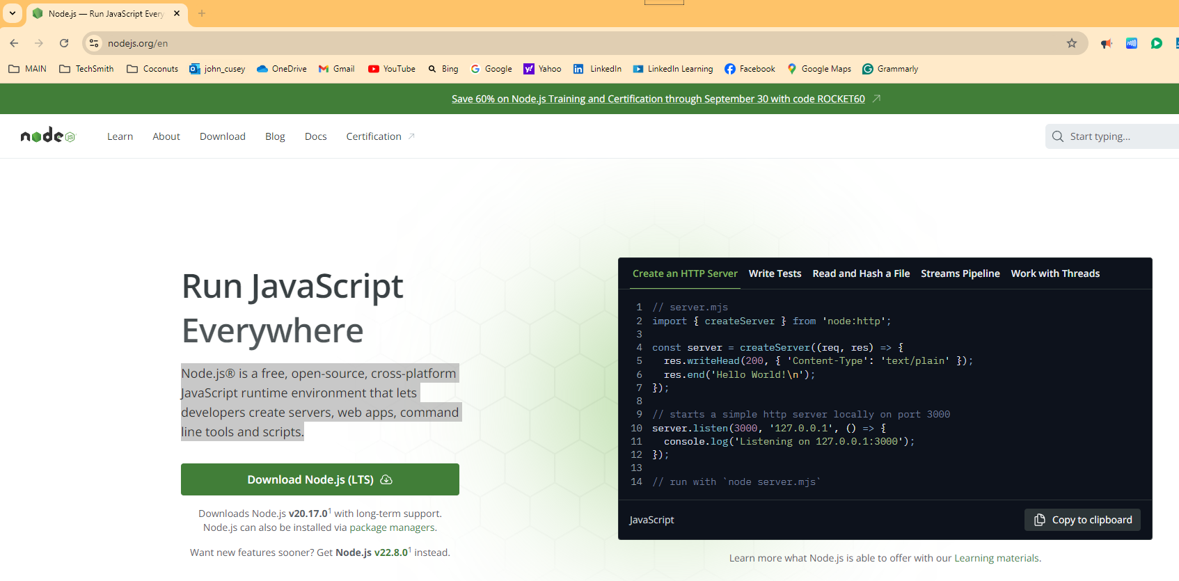
Another important software package to install is Node.js, an open-source, cross-platform runtime environment that allows you to execute JavaScript code outside of a web browser. It's built on Chrome's V8 JavaScript engine, which enables developers to use JavaScript for server-side scripting.
Node.js comes with NPM (Node Package Manager), the standard package manager for Node.js. The NPM webpage, npmjs.com, is the official site where you can browse packages, read documentation, and find general information about NPM. The site also offers resources for both free and Pro users, including various tools for JavaScript development.

https://nodejs.org/en

Using NPM to download jQuery
I'll demonstrate how to download a JavaScript library using jQuery as an example. I've chosen jQuery because it's commonly used and suitable for demonstration purposes.
- Open the work-space folder:
  - I was previously working in a directory called 'DIR' so to change the directory to 'work-space', do the following. Select 'Open Folder' and choose the desired folder.
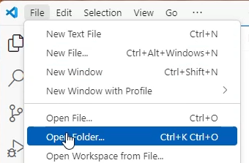
- Open a terminal window:
  - Launch a new terminal. By default, it opens in PowerShell.
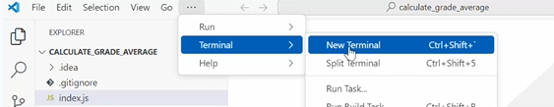
  - If you prefer, you can switch to Bash, provided you have Git Bash installed.
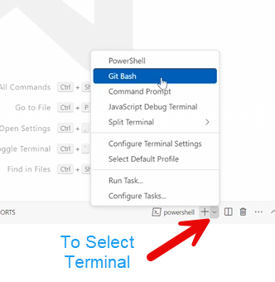
- Create a package.json file:
  - The package.json file will keep a list of all the JavaScript libraries you've installed.
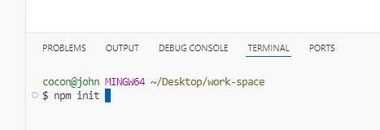
  - Run npm init and follow the prompts.
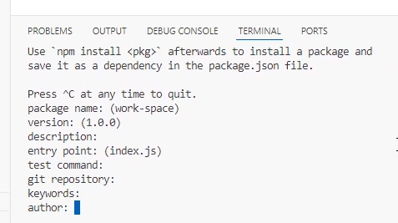
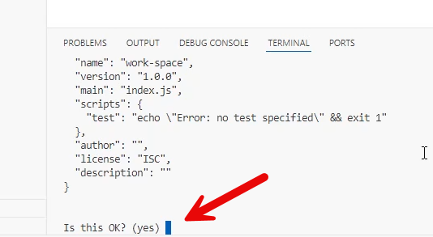
  - You can accept the default values by pressing enter than type 'yes'.

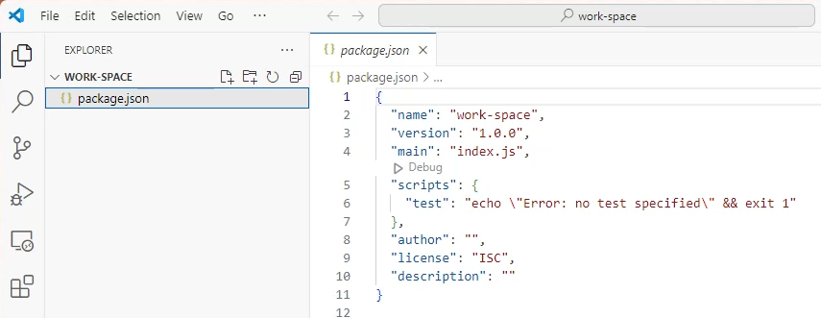

  - You can open the package.json file to view its contents.

- Install jQuery:
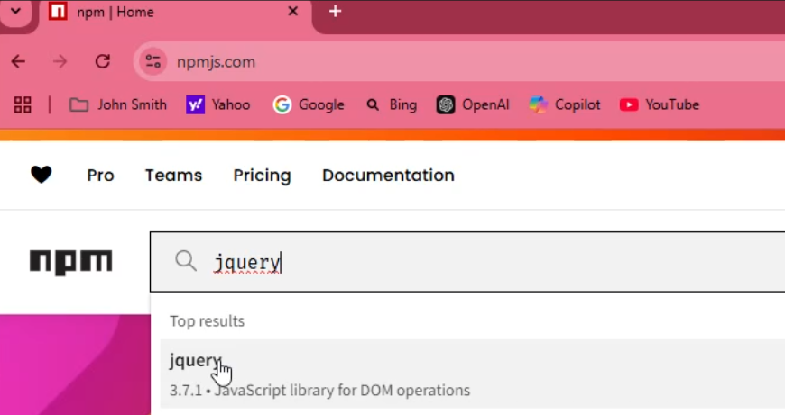
  - Visit the npm manage site and find the command for installing jQuery.
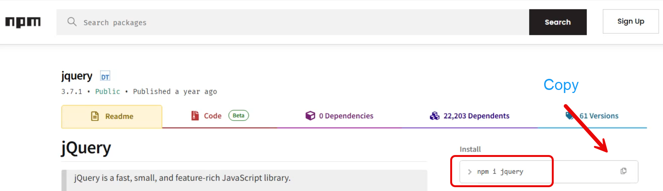
  - Copy the npm I jquery command, paste it into the terminal, and run it to install the library.
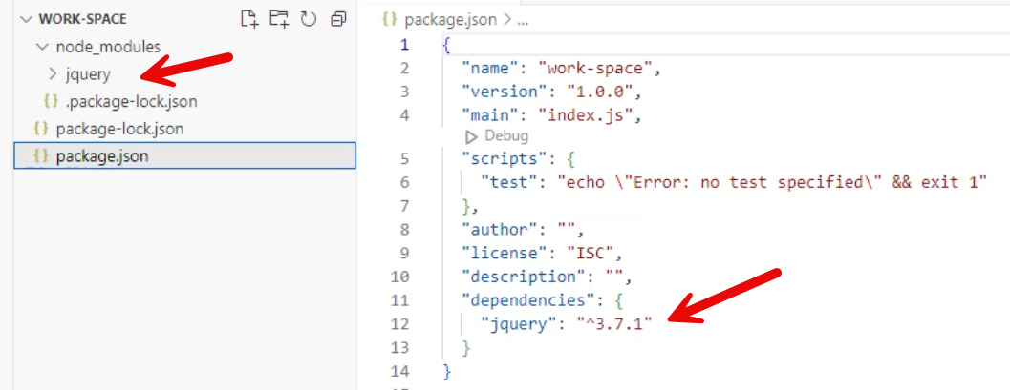
  - The library will be added to the dependencies in your package.json file.
- Remove Unwanted Library:
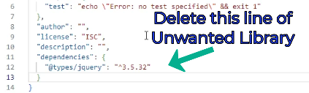
  - If you mistakenly add the wrong files, delete the unwanted entries from your package.json file.
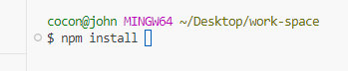
  - Run npm install to update the dependencies.
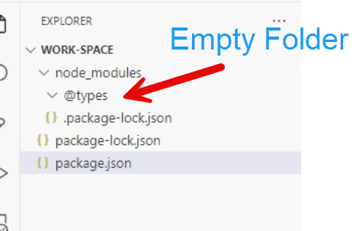
  - Perform a cleanup by letting the package manager handle deletions, then manually remove any leftover folders if necessary.

GitHub Desktop

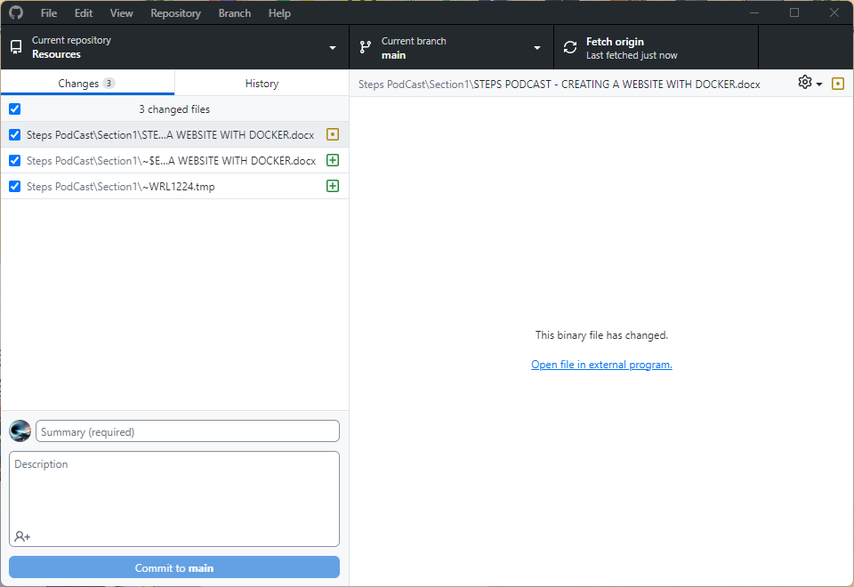

GitHub Desktop is a free, open-source application created to streamline your development workflow. It enables you to interact with GitHub repositories using a graphical user interface (GUI) rather than the command line or a web browser. You can decide which files to commit to your GitHub repository, and each commit will include the author's name and a commit message. If there are files you don't want to commit, you can add file path and file name to the .gitignore file.

https://github.com/apps/desktop

Visual Studio Code
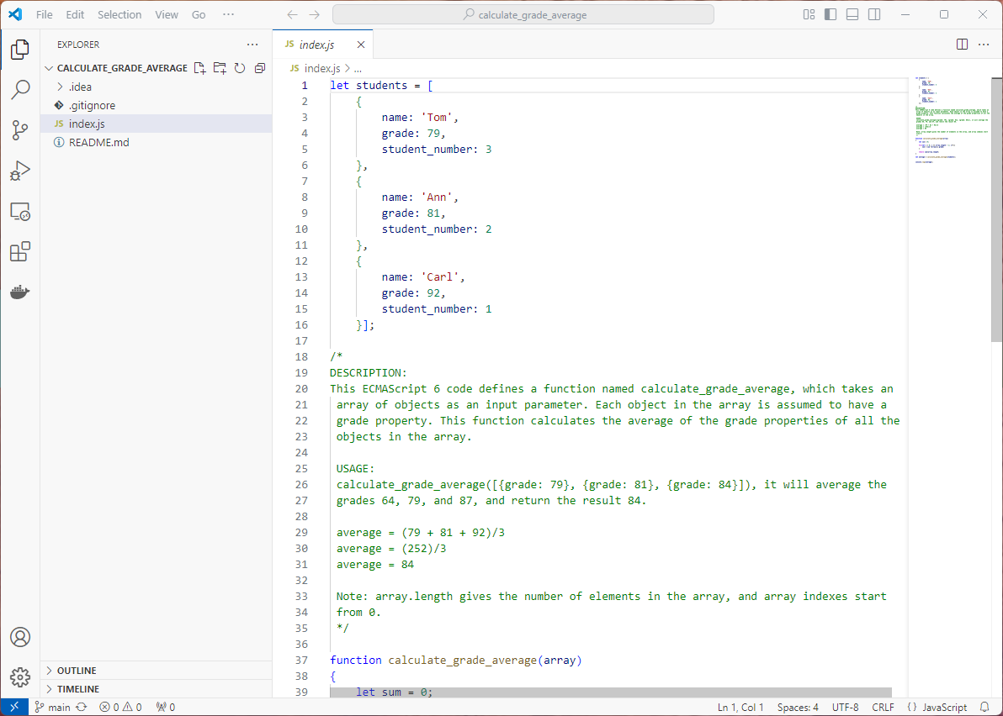
Visual Studio Code, commonly known as VS Code, is a free, lightweight, yet powerful source code editor developed by Microsoft. Its key features include integrated debugging tools, syntax highlighting to aid in reading and understanding code, intelligent code completion that suggests code based on context, reusable snippets of code, code refactoring tools to restructure code without changing its behavior, and built-in support for version control with Git.

https://code.visualstudio.com/

Using the Debugger for JavaScript Application
Today, I'm going to show you how to use the Visual Code JavaScript debugger.
- Open the index.js file:
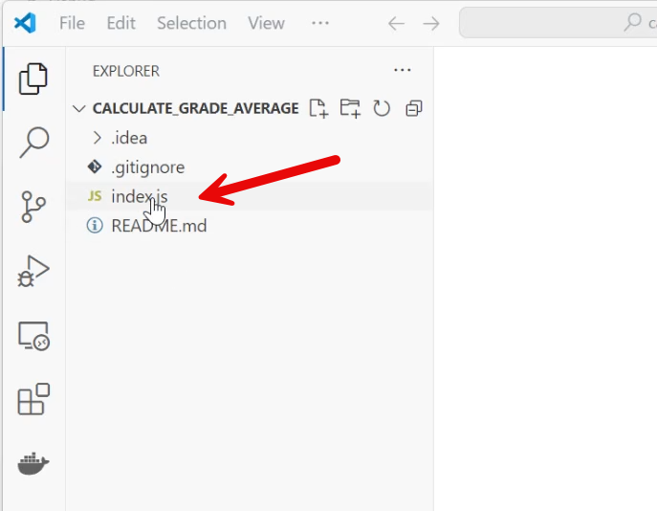
Open the index.js by clicking on the file.
- Set a breakpoint:
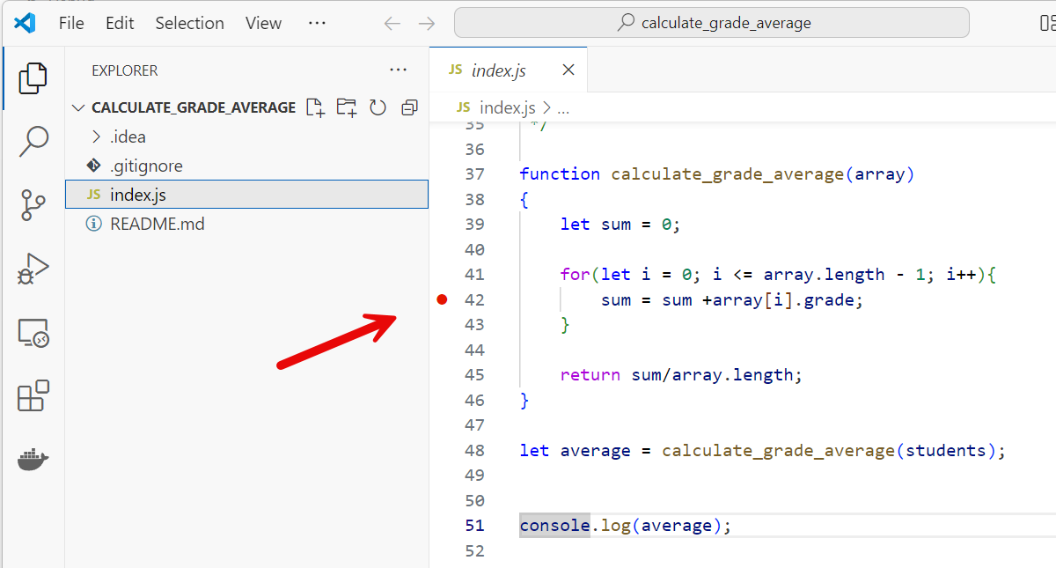
- Click on a line number where you want to add a breakpoint.
- When you see a red dot that indicates a breakpoint has been set.
- Open Debugger Tab:
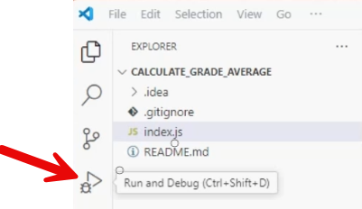
Click the debugger symbol on the left side menu.

- Run and Debug Button:
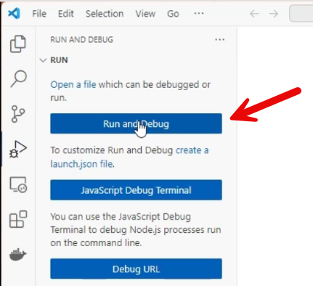
Click on the Run and Debug Button to start the debugger.
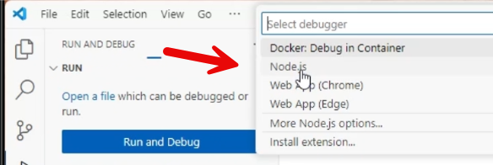
Select Node.js, as it's commonly used to run JavaScript applications outside the browser.
- Watch Expression and Step Over Button:
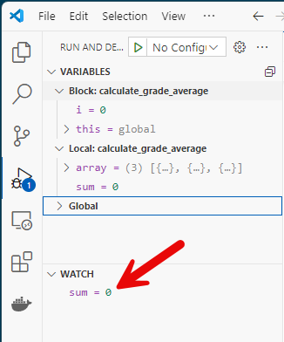
- To add a watch, go to the watch panel and add the expressions you want to monitor.
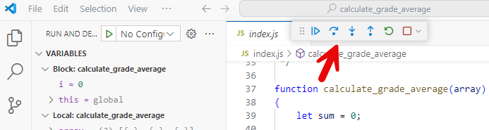
- Use 'Step Over' to see how variables change over time.
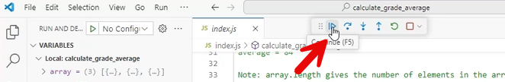
- To see the console outputs, continue running the code.

- Using Terminal Window:
If you prefer to run this through a terminal window, follow the steps below:
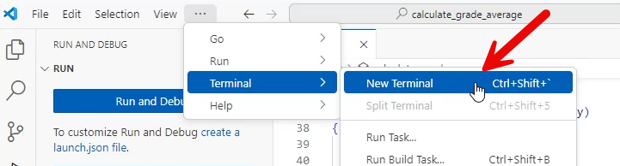
  - Open a terminal window.
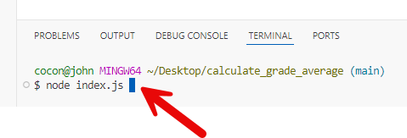
  - To run the program without the debugger type node and file name.

Docker Desktop
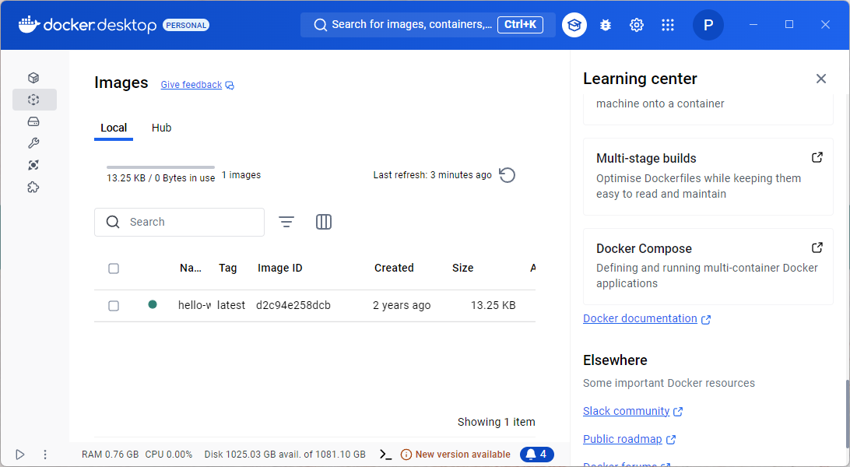
Docker Desktop is a widely used application that simplifies the process of building, sharing, and running containerized applications. It offers an intuitive user interface and comprehensive command line interface (CLI) tools to manage Docker containers and images seamlessly. With Docker Desktop, developers can create, test, and debug containers on their local machines before deploying them to production environments. It supports both Windows and macOS operating systems, making it a versatile tool for developers across different platforms.
Key features include Kubernetes integration, which allows developers to run Kubernetes clusters locally, and robust support for various programming languages and frameworks. Docker Desktop is essential for streamlining development workflows and ensuring consistency across different stages of application deployment.
https://www.docker.com/products/docker-desktop/

Docker

Introduction
Docker is an open-source platform that allows developers to automate the deployment of applications inside lightweight containers. These containers package all the dependencies and code your app needs to run, ensuring it works consistently across different environments.
Here’s a quick breakdown of Docker’s key features:
- Isolation: Each container runs in its own isolated environment, like a virtual machine but without the overhead of running a full operating system.
- Portability: Containers can run on any system that supports Docker, making it easy to move applications between different environments.
- Efficiency: Containers share the host system’s kernel, which makes them more lightweight and faster to start compared to virtual machines.
- Consistency: By packaging everything your application needs, Docker ensures that it runs the same way in development, testing, and production environments, reducing the “it works on my machine” problem.

Docker File

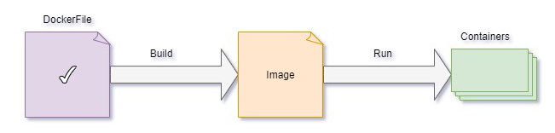
Figure 4.9
A Dockerfile is a text document that contains a series of instructions on how to build a Docker image. These instructions are executed step-by-step to create an image that can be used to run containers.
Here are some key points about Dockerfiles:
- Base Image: The FROM instruction specifies the base image to use for the Docker image.
- Commands: Instructions like RUN, CMD, and ENTRYPOINT define commands to be executed inside the container.
- File Operations: COPY and ADD are used to copy files and directories into the image.
- Environment Variables: ENV sets environment variables.
- Ports: EXPOSE specifies which ports the container will listen on.
- Metadata: LABEL adds metadata to the image.

Here’s a simple example of a Dockerfile:
# Use an official Python runtime as a parent image
FROM python:3.8-slim
# Set the working directory in the container
WORKDIR /app
# Copy the current directory contents into the container at /app
COPY . /app
# Install any needed packages specified in requirements.txt
RUN pip install --no-cache-dir -r requirements.txt
# Make port 80 available to the world outside this container
EXPOSE 80
# Define environment variable
ENV NAME World
# Run app.py when the container launches
CMD ["python", "app.py"]

This Dockerfile sets up a Python environment, installs dependencies, and runs a Python application.

Docker Image
What is Docker Image?
Docker images are built using the Dockerfile which consists of a set of instructions that are required to containerize an application. A Docker image is a file used to execute code in a Docker container. Docker images act as a set of instructions to build a Docker container, such as a template. Docker images also act as the starting point when using Docker. An image is comparable to a snapshot in virtual machine (VM) environments. Docker images have multiple layers, each originating from the previous layer but different. A docker image is a platform-independent image that can be built in the Windows environment and it can be pushed to the docker hub and pulled by others with different OS environments like Linux.

Docker Container
What is Docker Container?
A Docker container image is a lightweight, standalone, executable package of software that includes everything needed to run an application: code, runtime, system tools, system libraries and settings.
Think of a container as another form of virtualization. VMs, also just one form of virtualization, allow a piece of hardware to host multiple operating systems as software. VMs are added to the host machine so that the hardware power can be shared among different users and appear as separate servers or machines. Containers virtualize the OS, splitting it into virtualized compartments to run container applications.
Docker Daemon is responsible for the assembling and running of code as well as the distribution of the finalized containers. Docker Daemon takes the commands a developer enters the Docker client terminal and executes them.
This approach allows pieces of code to be put into smaller, easily transportable pieces that can run anywhere Linux or Windows is running. It’s a way to make applications even more distributed and strip them down into specific functions.

Docker Compose
Docker Compose is a tool that simplifies the process of defining and running multi-container Docker applications.
Here’s a quick overview of its key features:
- Configuration with YAML: You define your application’s services, networks, and volumes in a single YAML file. This makes it easy to manage and the version controls your configurations.
- Single Command Operations: With a single command (docker-compose up), you can start all the services defined in your configuration file. Similarly, you can stop, rebuild, and manage the lifecycle of your application with simple commands.
- Multi-Environment Support: Docker Compose works in various environments, including development, testing, staging, and production. This flexibility makes it a powerful tool for continuous integration (CI) workflows.
- Service Management: You can view the status of running services, stream log outputs, and run one-off commands on services, which helps in debugging and monitoring.
For example, if you’re developing a web application that requires a web server, a database, and a caching service, you can define all these components in a docker-compose.yml file and manage them together.

Create the Image
In the README file on GitHub, there is a section titled Usage Instructions where I explain how to Build the Docker image. Below, I will detail the Docker command used to build the image.
The command docker build -t node-docker-app . is used to build a Docker image from a Dockerfile. Here’s a breakdown of what each part of the command does:
- docker build: This is the Docker command to build an image from a Dockerfile.
- -t node-docker-app: The -t flag allows you to tag the image with a name. In this case, the image is tagged as node-docker-app.
- . : The period at the end specifies the build context, which is the current directory. Docker will look for a Dockerfile in this directory to build the image.
In summary, this command tells Docker to create an image named node-docker-app using the Dockerfile located in the current directory.

Images Menu
In Docker Desktop, click the Images Menu to view all the images.
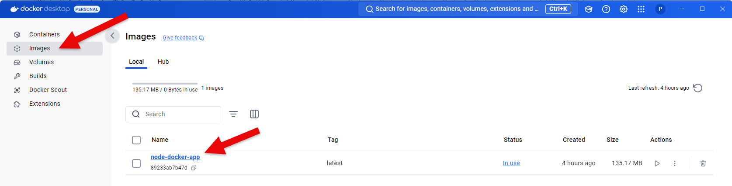
Figure 5.0
In Docker Desktop, when you can click on the image name (node-docker-app) you can view the image layers and hierarchy used to build the base image. See Figure 5.0
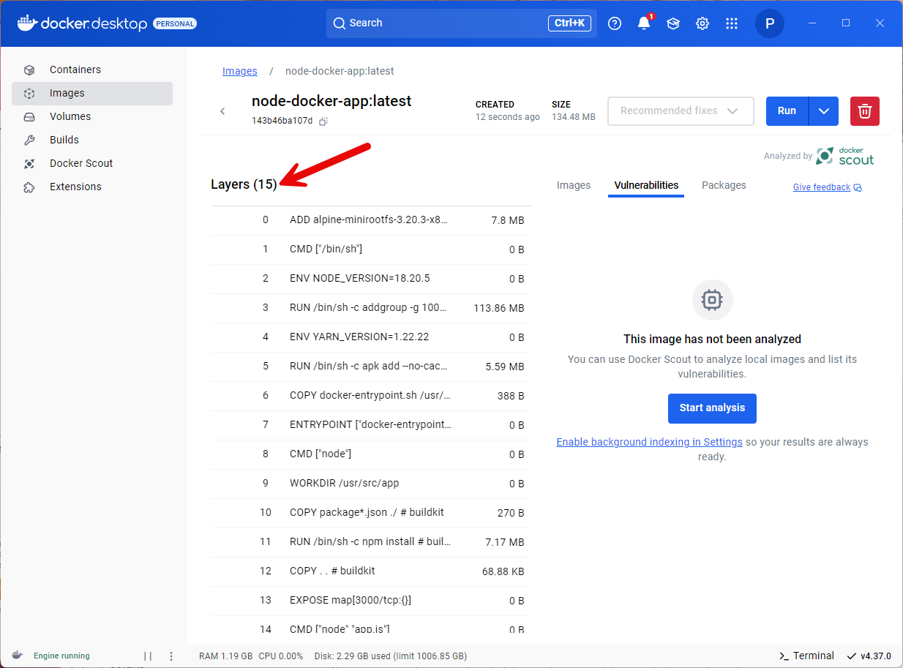
Figure 5.1
You can see the image’s 15 layers and the hierarchy, which is based on the Linux distribution that forms the base image. See Figure 5.1

Starting the Container
In the README file on GitHub, there is a section titled Usage Instructions where I explain How to start the Docker Container. Below, I will detail the Docker command used to start the container.
The command docker run -p 3000:3000 node-docker-app is used to run a Docker container from an image. Here’s a breakdown of what each part of the command does:
- docker run: This command is used to create and start a new container from a specified image.
- -p 3000:3000: This flag maps port 3000 on your host machine to port 3000 in the container. This means that any traffic to port 3000 on your host will be forwarded to port 3000 in the container.
- node-docker-app: This is the name of the Docker image from which the container will be created.
In summary, this command starts a container from the node-docker-app image and maps port 3000 on your local machine to port 3000 in the container, allowing you to access the application running inside the container via http://localhost:3000.
In Docker Desktop, click the Containers vertical menu to view all the containers.
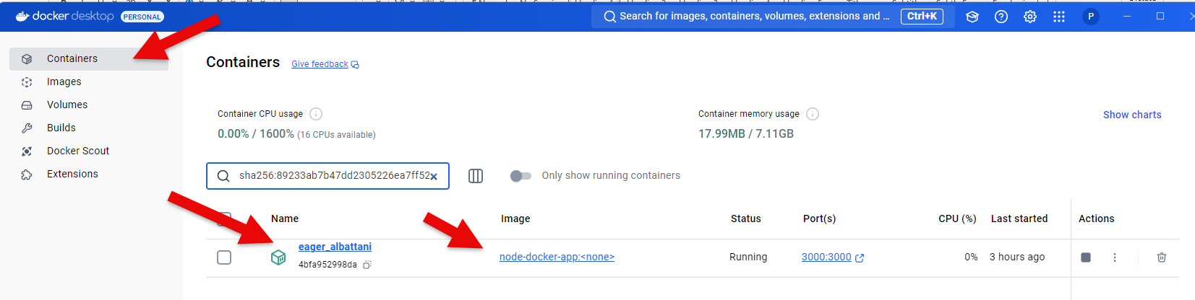
Figure 5.2
In Docker Desktop, clicking on the container name (eager_albattani) allows you to view the file structure, log files, and access a command line to run Linux commands. The container name is generated by the daemon engine.

Command Line
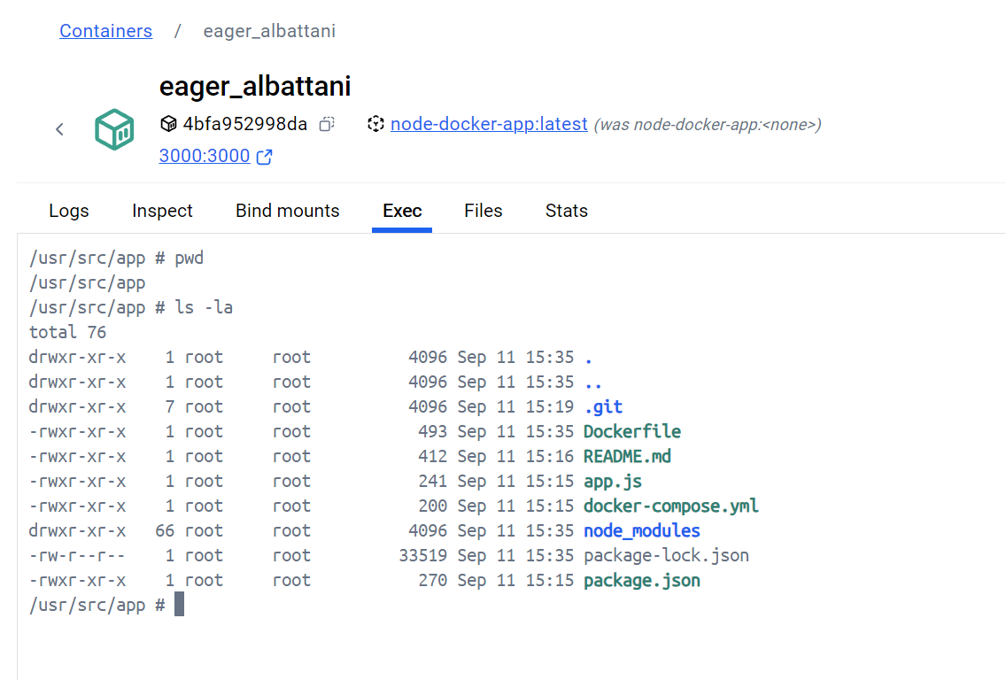
Figure 5.3
Accessing the command line is excellent for debugging your container while it’s running.

File Structure
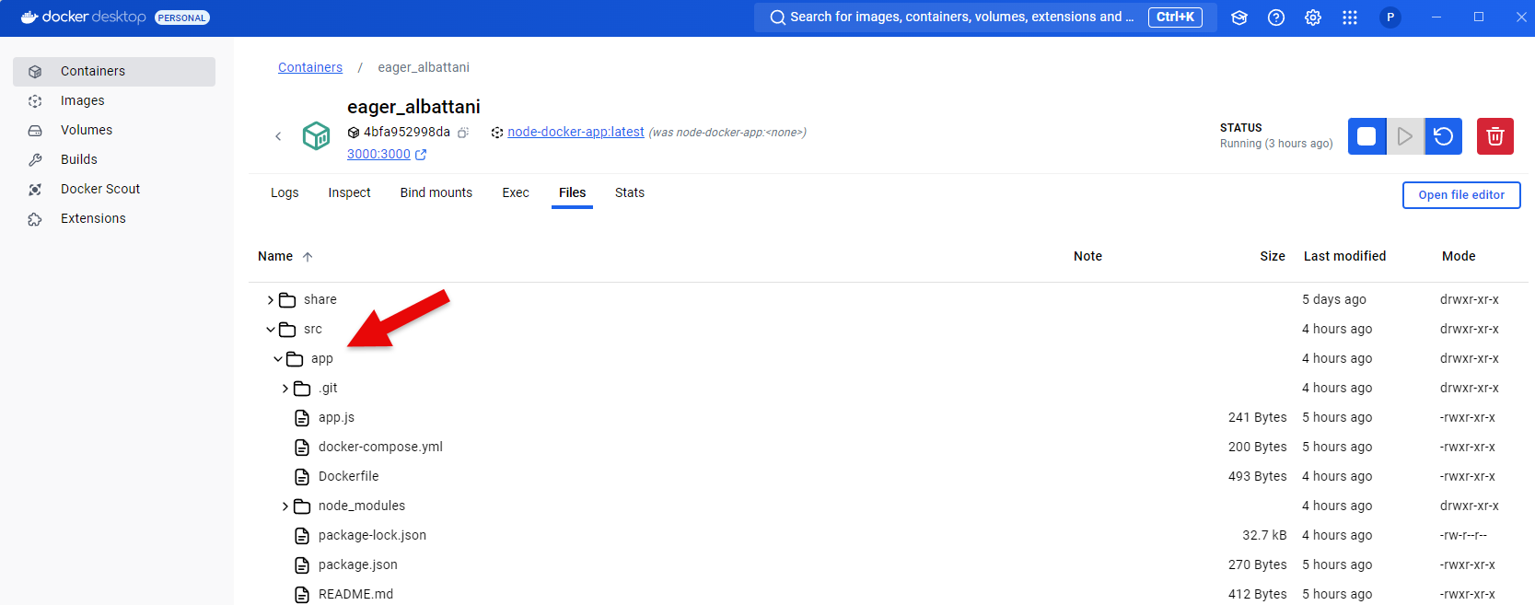
Figure 5.4
Another excellent debugging tool is the ability to inspect the file structure.

Website in the Container
When the container is running you can view the webpage on the Express server.
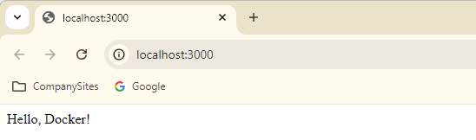
Figure 5.5

Difference Between RUN and CMD in Dockerfile
RUN and CMD are both instructions used in Dockerfiles, but they have different purposes.

RUN instruction
RUN is used to execute commands during the build process of a Docker image. These commands are run on a new layer on top of the current image and their result is saved in the new image layer. The commands specified with RUN are typically used to install software packages, update system configurations, create directories, and perform other tasks that are necessary to configure the image.

CMD instruction
CMD, on the other hand, is used to specify the default command to run when a Docker container is started from the image. This command is only executed when the container is started, and it can be overridden by passing a different command to the docker run command line. CMD is typically used to start a service or application in the container.

Summarize CMD and RUN instruction
To summarize, RUN is used to execute commands during the build process of a Docker image, while CMD is used to specify the default command to run when a Docker container is started from the image.

